SALVI TUNNEL ENGINE
Informe Técnico de Iluminación de Túneles

Norma: CIE 88:2004 — Guide for the Lighting of Road Tunnels and Underpasses

Proyecto | Validaci?n ampliada
Tubo | T1
Longitud total | 300.0 m
Velocidad de diseño | 80.0 km/h
Tráfico de diseño | 500 veh/h
Clasificación óptica | optically long
Iluminación diurna | normal
Fecha del informe | 30/07/2026

Redactado con SALVI Tunnel Engine (STE) — Motor de cálculo conforme a CIE 88:2004.

1. Resumen de Validación

REVISAR — Existe al menos un criterio de perfil o de calidad fotométrica que no cumple.
Tubo / longitud | T1 / 300.0 m
Condición de diseño | 80.0 km/h · SD 145.3 m
Portal A | L20 4785.0 cd/m² · Lth 228.0 cd/m²
Portal B | L20 3045.0 cd/m² · Lth 140.0 cd/m²
Interior / noche | Lin 3.0 cd/m² · L noche 1.0 cd/m²
Instalación calculada | 286 luminarias · 80.09 kW instalados
Condicionantes: ⚠️ Túnel bidireccional corto: layout truncado a Lth_A=145 m, Lth_B=136 m, Ltr_A=3 m, Ltr_B=6 m. · Salto de respaldo 'Cubierto'/'Crepuscular' = 17.3:1; considerar una escena intermedia. · Capa ADAPTACIÓN crepuscular añadida: A=9 luminarias, B=8 luminarias, malla d=18.0 m desplazada medio vano y margen 12%.
2. Datos de Partida y Alcance

Geometría, tráfico y explotación

Longitud del tubo | 300.0 m
Calzada | 10.5 m · 2 carriles de 3.5 m
Sección / altura | Horseshoe · 5.5 m
Circulación | Two Way
Velocidad / distancia de parada | 80.0 km/h · 145.3 m
Pendiente / fricción | 1.5 % · μ=None
Tráfico de proyecto | 500 veh/h
Pavimento | Asfalto Oscuro (R3)
Entorno y parámetros luminotécnicos

Método L20 / entorno | Model · Open Country Flat
Orientación / cielo | S · Clear
Portal A: L20 / Lth | 4785.0 / 228.0 cd/m²
Portal B: L20 / Lth | 3045.0 / 140.0 cd/m²
Factor de mantenimiento | 0.7
Reflectancias | Paredes ρ=0.4 · Techo ρ=0.25

3. Criterios y Metodología

- La luminancia de adaptación se determina para cada portal con el método L20. A partir de ella se obtiene la luminancia de umbral y el perfil longitudinal exigido según CIE 88:2004.
- El tubo se divide en zonas de umbral, transición e interior. Cuando hay circulación bidireccional, ambos portales se calculan de forma independiente y se conserva el caso más desfavorable en cada comprobación.
- La instalación se dimensiona con los ficheros fotométricos de las luminarias. La verificación se realiza sobre campos bidimensionales CIE 140:2019: luminancia media, uniformidad general U0, uniformidad longitudinal Ul e incremento de umbral TI.
4. Resultado Luminotécnico — Perfil Longitudinal

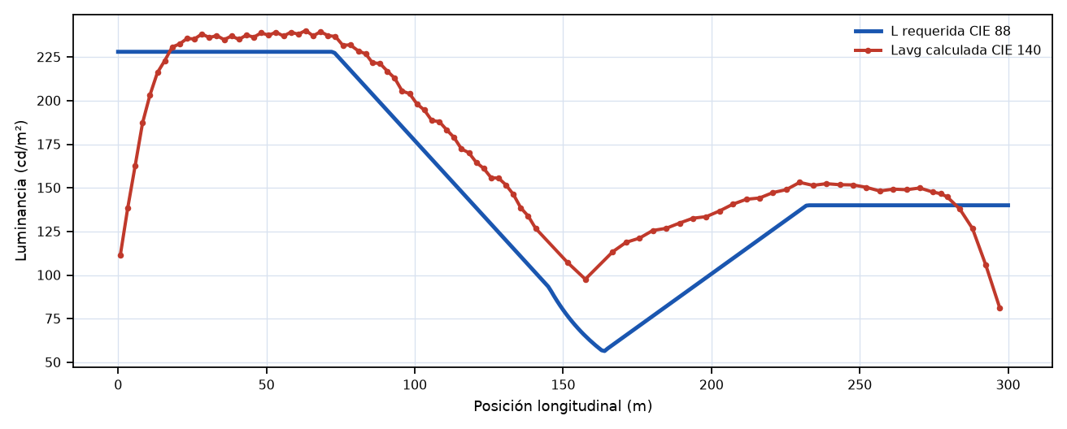
La curva roja procede exclusivamente de Lavg calculada en campos bidimensionales CIE 140 entre luminarias consecutivas.
Cumplimiento por zona

Zona | Lavg / Lreq | U0 | Ul | TI (%) | Estado
CTH | 234.96 / 228.0 | 0.857 | 0.914 | 29.5 | REVISAR
CTR1 | 107.21 / 76.63 | 0.876 | 0.845 | 33.3 | REVISAR
CTH·B | 146.69 / 140.0 | 0.755 | 0.914 | 25.9 | REVISAR

5. Diseño de la Instalación

Disposición | Bilateral Sym
Luminaria de referencia | Aphex APHEX_L_320Wx2/Aphex L 320W x2 469mA 4000K
Óptica / CCT / I máx. | F151 · 4000K · 500 mA
Total instalado | 286 luminarias · 80.09 kW
Densidad media | 25.43 W/m²

Zona | Tramo (m) | Modelo / óptica | mA | W | d (m) | N | Tilt | Capa
BASE A–B | 0.0–300.0 | APHEX_S_75W / F151 | 375 | 58.0 | 20.0 | 34 | 10.0° | Permanent
ADAPTACIÓN A | 0.0–300.0 | APHEX_M_200Wx2 / F151 | 256 | 156.0 | 18.0 | 18 | 10.0° | Adaptation
ADAPTACIÓN B | 0.0–300.0 | APHEX_S_165W / F151 | 242 | 74.0 | 18.0 | 16 | -10.0° | Adaptation
CTH | 0.0–145.3 | APHEX_L_320Wx2 / F2M2 | 469 | 436.0 | 5.0 | 116 | 20.0° | Reinforcement
CTR1 | 145.3–300.0 | APHEX_L_320Wx2 / F151 | 417 | 386.0 | 6.0 | 22 | 15.0° | Reinforcement
CTR2·B | 0.0–164.3 | APHEX_L_320Wx2 / F151 | 418 | 387.0 | 18.0 | 16 | 20.0° | Reinforcement
CTH·B | 164.3–300.0 | APHEX_S_75W / F151 | 215 | 33.0 | 4.5 | 64 | 20.0° | Reinforcement
6. Plano de Implantación de Luminarias

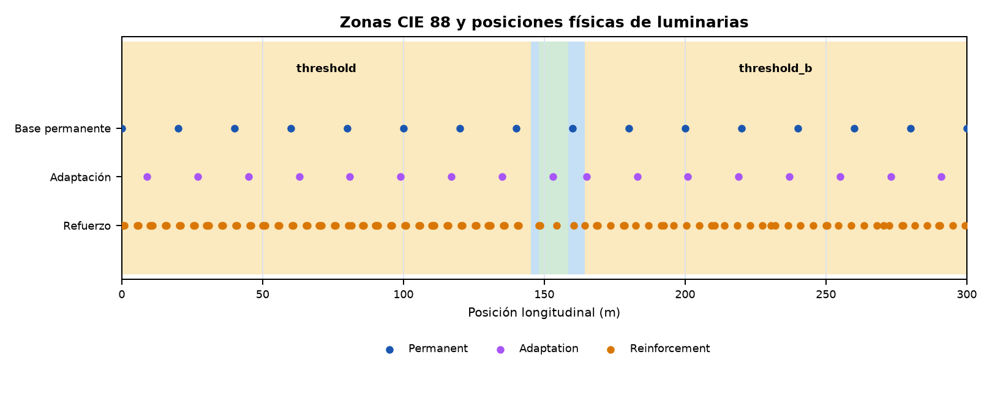
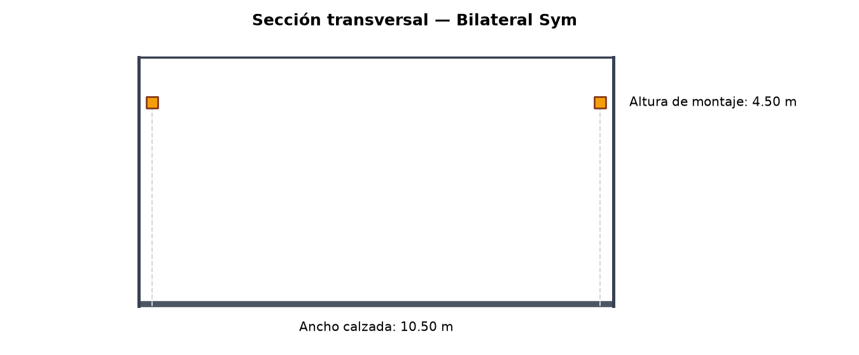
7. Control DALI y Escenas de Operación

Protocolo de control | DALI
Nº de grupos | 7
Nº de escenas | 5

Tabla de Regulación (grupos × escenas)

Grupo | L diseño  (cd/m²) | Soleado  L₂₀=4785 | Normal  L₂₀=3350 | Cubierto  L₂₀=1436 | Crepuscular  L₂₀=239 | Noche  L₂₀=0
BASE — Permanente A–B | 3.0 | 100.0%  DALI 254 | 100.0%  DALI 254 | 100.0%  DALI 254 | 100.0%  DALI 254 | 33.3%  DALI 214
REF-A-TH — Umbral A | 225.0 | 99.8%  DALI 254 | 69.5%  DALI 241 | 29.0%  DALI 209 | 3.7%  DALI 133 | 0.0%
REF-A-TR1 — Transición A 1/2 | 87.7 | 99.8%  DALI 254 | 68.8%  DALI 240 | 27.5%  DALI 207 | 1.7%  DALI 106 | 0.0%
REF-A-TR2 — Transición A 2/2 | 83.7 | 99.8%  DALI 254 | 68.8%  DALI 240 | 27.4%  DALI 207 | 1.6%  DALI 102 | 0.0%
REF-B-TR1 — Transición B 1/2 | 46.7 | 99.9%  DALI 254 | 68.0%  DALI 240 | 25.5%  DALI 204 | 0.0% | 0.0%
REF-B-TR2 — Transición B 2/2 | 51.4 | 99.9%  DALI 254 | 68.2%  DALI 240 | 25.9%  DALI 205 | 0.0% | 0.0%
REF-B-TH — Umbral B | 137.0 | 99.9%  DALI 254 | 69.3%  DALI 241 | 28.4%  DALI 208 | 2.9%  DALI 125 | 0.0%
CTH=Umbral · CTRn=Transición · CIN=Interior · CEX=Salida. Niveles DALI según IEC 62386 (curva logarítmica, rango 0–254).
Potencia por escena de operación

Escena | Luminarias activas | Potencia (kW) | Flujo (lm)
Soleado | 252 | 75.956 | 13922882.0
Noche | 34 | 0.59 | 121812.0
Soleado | 252 | 75.956 | 13922882.0
Normal | 252 | 50.516 | 9708780.0
Cubierto | 246 | 21.51 | 4414666.0
Crepuscular | 68 | 4.922 | 930402.0
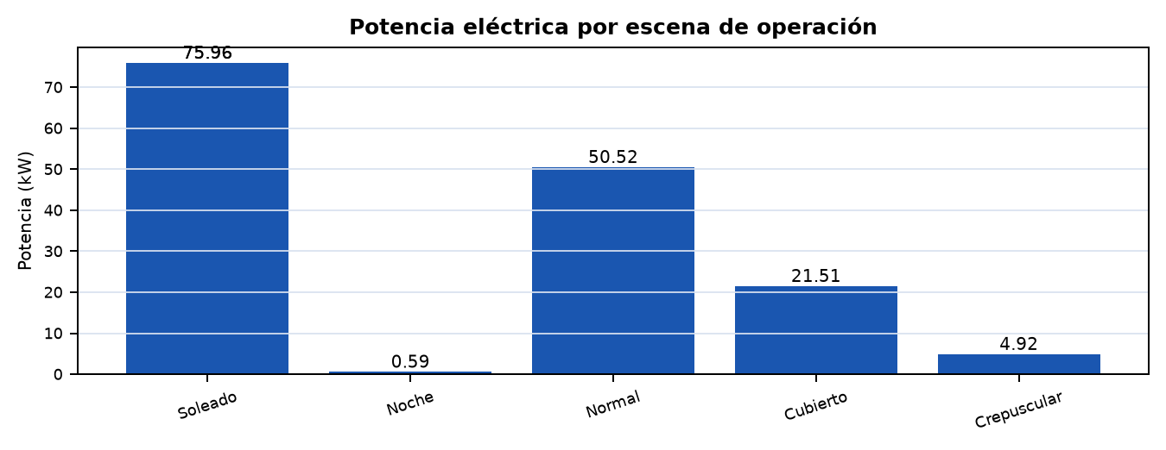
8. Conclusiones y Verificaciones de Recepción

Estado del diseño: REVISAR. Existe al menos un criterio de perfil o de calidad fotométrica que no cumple.
- Verificar en obra la geometría efectiva, la posición transversal y la altura de montaje de cada fila.
- Comprobar que modelo, óptica, flujo, corriente y orientación/tilt coinciden con el listado de luminarias.
- Programar y ensayar las escenas y grupos DALI antes de la recepción de la instalación.
- Confirmar las condiciones de mantenimiento y las reflectancias adoptadas si difieren de las existentes en obra.

ANEXOS DE CÁLCULO E INSTALACIÓN

Los anexos conservan la trazabilidad necesaria para auditoría, dirección facultativa y puesta en marcha.
ANEXO A. Clasificación y Distancia de Parada

Clasificación geométrica | long
Clasificación óptica | optically long
Necesidad de ilum. diurna | normal
Distancia de parada (SD) | 145.3 m
Distancia de reacción (dr) | 33.3 m
Distancia de frenado (df) | 112.0 m
Justificación: Longitud: 300 m → long. Clasificación óptica: salida no visible desde SD=145 m, penetración de luz: poor → optically_long. Necesidad de iluminación diurna: normal.
ANEXO A.2 Datos L20, Lth e Interior

L₂₀ — Luminancia campo 20° | 4785.0 cd/m²
Método de cálculo L₂₀ | model
Confianza del valor L₂₀ | Media
Lth — Luminancia de umbral | 228.0 cd/m²
Factor k (Lth = k · L₂₀) | 0.0476
Coef. revelación contraste qc | 0.1
Lseq — Luminancia equivalente | 4785.0 cd/m²
Lin — Luminancia interior | 3.0 cd/m²
L_noche — Luminancia nocturna | 1.0 cd/m²
Nota L₂₀: Modelo entorno: open_country_flat, orientación: S, cielo: clear
ANEXO A.3 Zonas y Perfil Normativo

Zona | s inicio (m) | s fin (m) | Longitud (m) | L inicio (cd/m²) | L fin (cd/m²) | L mín. req. (cd/m²)
Threshold | 0.0 | 145.3 | 145.3 | 228.00 | 92.83 | 228.00
Transition | 145.3 | 148.1 | 2.8 | 92.83 | 3.00 | 3.00
Interior | 148.1 | 158.5 | 10.4 | 3.00 | 3.00 | 3.00
Transition B | 158.5 | 164.3 | 5.8 | 3.00 | 57.00 | 3.00
Threshold B | 164.3 | 300.0 | 135.7 | 57.00 | 140.00 | 140.00
ANEXO B. Verificación Fotométrica CIE 140:2019

CIE 140:2019 · Tabla R3 · Optica F151 · H = 4.5 m
Zona | L_avg / L_req | U0 >=0.40 | Ul >=0.60 | TI <=15% | Estado
CTH | 234.96 / 228.0 | 0.857 | 0.914 | 29.5 | REVISAR
CTR1 | 107.21 / 76.63 | 0.876 | 0.845 | 33.3 | REVISAR
CTH·B | 146.69 / 140.0 | 0.755 | 0.914 | 25.9 | REVISAR

Verificación por carril y sentido

Zona | Carril | Sentido | L / Lreq | U0 carril* | Ul | TI | Estado
CTH | 1 | A → B | 228.756 / 228.0 | 0.9422 | 0.9141 | 22.812 | REVISAR
CTH | 2 | A → B | 251.88 / 228.0 | 0.8931 | 0.9372 | 29.522 | REVISAR
CTR1 | 1 | A → B | 114.39 / 76.626 | 0.8868 | 0.8671 | 25.371 | REVISAR
CTR1 | 2 | A → B | 106.662 / 76.626 | 0.9027 | 0.8448 | 33.32 | REVISAR
CTH·B | 1 | B → A | 147.159 / 140.0 | 0.836 | 0.9138 | 18.108 | REVISAR
CTH·B | 2 | B → A | 156.436 / 140.0 | 0.9131 | 0.9275 | 25.878 | REVISAR
* U0 por carril es un diagnóstico adicional. La conformidad normativa de U0 se calcula sobre toda la calzada para cada observador; Ul se verifica sobre el eje de cada carril. En el resumen gobierna el peor resultado.

Criterio | Requisito | Estado
CIE 140:2019 global | todas las zonas | REVISAR
Perfil longitudinal normativo | CIE 88:2004 | CUMPLE
Ratios de transicion | <= 3:1 | CUMPLE

Advertencias del cálculo

- ⚠️ Túnel bidireccional corto: layout truncado a Lth_A=145 m, Lth_B=136 m, Ltr_A=3 m, Ltr_B=6 m.
- Salto de respaldo 'Cubierto'/'Crepuscular' = 17.3:1; considerar una escena intermedia.

ANEXO B.1. Campos CIE 140 — CTH

Campo (m) | Lavg | L req. | U0 | Ul | TI (%) | Caso gobernante
0.5–1.0 | 111.34 | — | 0.872 | 0.961 | 1.0 | C2 / A→B
1.0–5.5 | 138.44 | — | 0.741 | 0.729 | 0.8 | C2 / A→B
5.5–6.0 | 162.66 | — | 0.915 | 0.971 | 0.8 | C2 / A→B
6.0–10.5 | 187.25 | — | 0.823 | 0.816 | 0.7 | C2 / A→B
10.5–11.0 | 203.28 | — | 0.935 | 0.988 | 0.7 | C2 / A→B
11.0–15.5 | 216.05 | — | 0.883 | 0.916 | 0.7 | C2 / A→B
15.5–16.0 | 222.99 | — | 0.916 | 0.994 | 0.7 | C2 / A→B
16.0–20.5 | 230.75 | — | 0.883 | 0.957 | 0.8 | C2 / A→B
20.5–21.0 | 232.50 | — | 0.903 | 0.999 | 0.8 | C2 / A→B
21.0–25.5 | 235.65 | — | 0.883 | 0.978 | 0.9 | C2 / A→B
25.5–26.0 | 235.35 | — | 0.915 | 0.999 | 0.9 | C2 / A→B
26.0–30.5 | 238.20 | — | 0.902 | 0.978 | 1.0 | C2 / A→B
30.5–31.0 | 236.15 | — | 0.913 | 0.998 | 1.1 | C2 / A→B
31.0–35.5 | 237.29 | — | 0.894 | 0.979 | 1.3 | C2 / A→B
35.5–36.0 | 234.96 | — | 0.901 | 0.999 | 1.7 | C2 / A→B
36.0–40.5 | 237.08 | — | 0.885 | 0.980 | 2.4 | C2 / A→B
40.5–41.0 | 235.10 | — | 0.903 | 0.998 | 3.2 | C2 / A→B
41.0–45.5 | 237.60 | — | 0.887 | 0.982 | 4.3 | C2 / A→B
45.5–46.0 | 236.38 | — | 0.917 | 0.999 | 5.4 | C2 / A→B
46.0–50.5 | 238.87 | — | 0.898 | 0.976 | 6.5 | C2 / A→B
50.5–51.0 | 237.48 | — | 0.910 | 0.998 | 7.7 | C2 / A→B
51.0–55.5 | 239.25 | — | 0.892 | 0.978 | 8.7 | C2 / A→B
55.5–56.0 | 237.03 | — | 0.900 | 0.998 | 9.6 | C2 / A→B
56.0–60.5 | 239.23 | — | 0.883 | 0.981 | 10.3 | C2 / A→B
60.5–61.0 | 238.10 | — | 0.912 | 0.999 | 10.8 | C2 / A→B
61.0–65.5 | 240.22 | — | 0.901 | 0.982 | 11.6 | C2 / A→B
65.5–66.0 | 237.13 | — | 0.914 | 0.999 | 12.7 | C2 / A→B
66.0–70.5 | 239.52 | — | 0.898 | 0.978 | 13.7 | C2 / A→B
70.5–71.0 | 237.32 | — | 0.910 | 0.997 | 14.9 | C2 / A→B
71.0–75.5 | 236.77 | — | 0.894 | 0.974 | 16.0 | C2 / A→B
75.5–76.0 | 231.76 | — | 0.902 | 0.997 | 17.1 | C2 / A→B
76.0–80.5 | 231.97 | — | 0.891 | 0.976 | 18.0 | C2 / A→B
80.5–81.5 | 228.49 | — | 0.914 | 0.994 | 18.8 | C2 / A→B
81.5–85.5 | 226.78 | — | 0.901 | 0.971 | 19.4 | C2 / A→B
85.5–86.0 | 221.67 | — | 0.911 | 0.996 | 19.7 | C2 / A→B
86.0–90.5 | 221.38 | — | 0.901 | 0.976 | 20.1 | C2 / A→B
90.5–91.0 | 216.93 | — | 0.910 | 0.995 | 20.4 | C2 / A→B
91.0–95.5 | 212.87 | — | 0.886 | 0.951 | 20.9 | C2 / A→B
95.5–96.0 | 205.52 | — | 0.905 | 0.994 | 21.3 | C2 / A→B
96.0–100.5 | 204.00 | — | 0.903 | 0.968 | 21.6 | C2 / A→B
100.5–101.0 | 198.10 | — | 0.912 | 0.992 | 21.9 | C2 / A→B
101.0–105.5 | 194.58 | — | 0.889 | 0.958 | 22.4 | C2 / A→B
105.5–106.0 | 188.57 | — | 0.906 | 0.995 | 22.8 | C2 / A→B
106.0–110.5 | 188.01 | — | 0.899 | 0.968 | 23.1 | C2 / A→B
110.5–111.0 | 183.27 | — | 0.913 | 0.993 | 23.5 | C2 / A→B
111.0–115.5 | 178.87 | — | 0.892 | 0.946 | 24.1 | C2 / A→B
115.5–116.0 | 172.32 | — | 0.913 | 0.994 | 24.6 | C2 / A→B
116.0–120.5 | 170.11 | — | 0.893 | 0.965 | 24.9 | C2 / A→B
120.5–121.0 | 164.54 | — | 0.906 | 0.994 | 25.3 | C2 / A→B
121.0–125.5 | 161.16 | — | 0.879 | 0.954 | 25.8 | C2 / A→B
125.5–126.0 | 155.79 | — | 0.899 | 0.994 | 26.2 | C2 / A→B
126.0–130.5 | 155.61 | — | 0.895 | 0.966 | 26.4 | C2 / A→B
130.5–131.0 | 151.65 | — | 0.921 | 0.992 | 26.6 | C2 / A→B
131.0–135.5 | 146.25 | — | 0.877 | 0.914 | 27.4 | C2 / A→B
135.5–136.0 | 138.52 | — | 0.901 | 0.990 | 28.1 | C2 / A→B
136.0–140.5 | 133.81 | — | 0.857 | 0.937 | 28.9 | C2 / A→B
140.5–141.0 | 126.76 | — | 0.878 | 0.988 | 29.5 | C2 / A→B
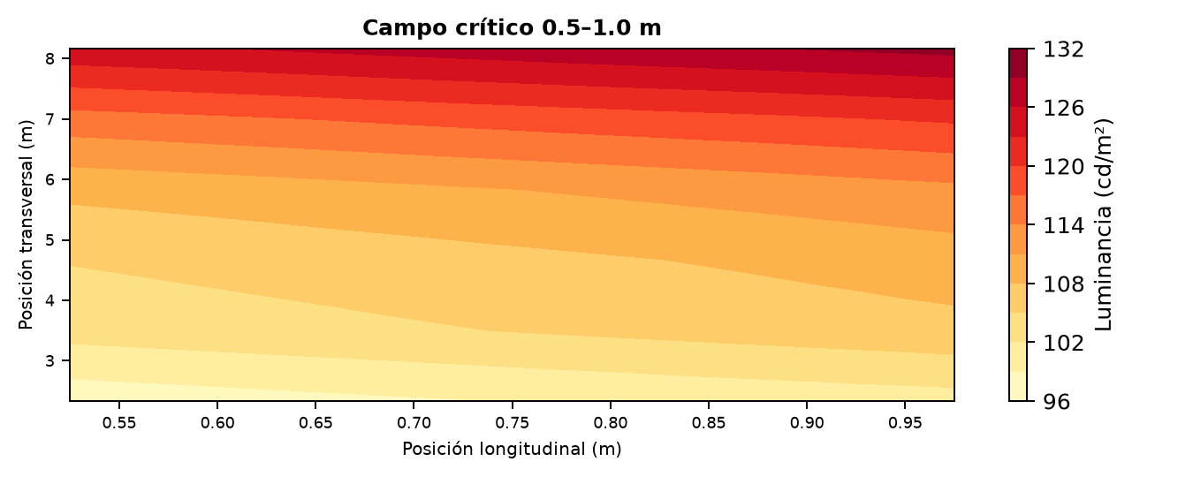

ANEXO B.2. Campos CIE 140 — CTR1

Campo (m) | Lavg | L req. | U0 | Ul | TI (%) | Caso gobernante
148.5–154.5 | 107.21 | — | 0.876 | 0.845 | 32.1 | C2 / A→B
154.5–160.5 | 97.62 | — | 0.910 | 0.967 | 33.3 | C2 / A→B
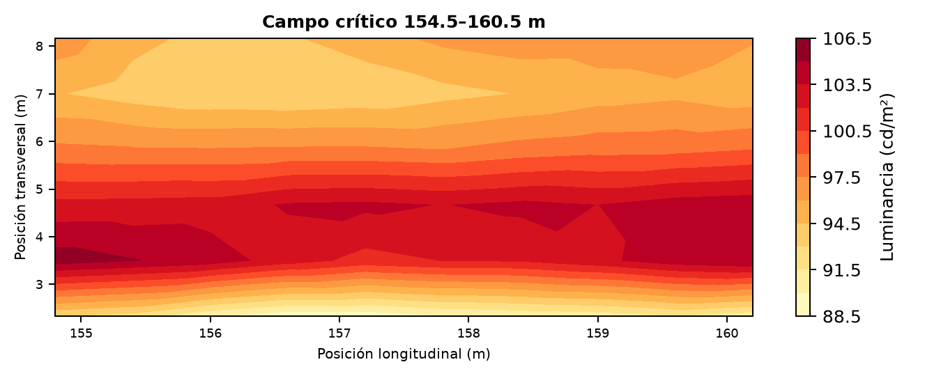

ANEXO B.3. Campos CIE 140 — CTH·B

Campo (m) | Lavg | L req. | U0 | Ul | TI (%) | Caso gobernante
164.5–169.0 | 113.37 | — | 0.830 | 0.914 | 25.9 | C2 / B→A
169.0–173.5 | 118.77 | — | 0.810 | 0.947 | 25.3 | C2 / B→A
173.5–178.0 | 121.16 | — | 0.794 | 0.963 | 25.2 | C2 / B→A
178.0–182.5 | 125.55 | — | 0.787 | 0.969 | 25.2 | C2 / B→A
182.5–187.0 | 126.80 | — | 0.781 | 0.976 | 25.0 | C2 / B→A
187.0–191.5 | 129.80 | — | 0.778 | 0.971 | 24.7 | C2 / B→A
191.5–196.0 | 132.58 | — | 0.776 | 0.976 | 24.4 | C2 / B→A
196.0–200.5 | 133.48 | — | 0.775 | 0.972 | 24.5 | C2 / B→A
200.5–205.0 | 136.75 | — | 0.777 | 0.973 | 24.1 | C2 / B→A
205.0–209.5 | 140.63 | — | 0.770 | 0.968 | 23.1 | C2 / B→A
209.5–214.0 | 143.43 | — | 0.765 | 0.986 | 22.2 | C2 / B→A
214.0–218.5 | 144.20 | — | 0.767 | 0.967 | 21.2 | C2 / B→A
218.5–223.0 | 147.29 | — | 0.785 | 0.969 | 19.9 | C2 / B→A
223.0–227.5 | 148.97 | — | 0.804 | 0.967 | 17.8 | C2 / B→A
227.5–232.0 | 153.14 | — | 0.826 | 0.971 | 15.4 | C2 / B→A
232.0–236.5 | 151.41 | — | 0.778 | 0.960 | 13.7 | C2 / B→A
236.5–241.0 | 152.39 | — | 0.774 | 0.979 | 12.4 | C2 / B→A
241.0–245.5 | 151.80 | — | 0.780 | 0.985 | 11.5 | C2 / B→A
245.5–250.0 | 151.68 | — | 0.801 | 0.978 | 10.2 | C2 / B→A
250.0–254.5 | 150.28 | — | 0.771 | 0.955 | 8.7 | C2 / B→A
254.5–259.0 | 148.20 | — | 0.755 | 0.981 | 6.8 | C2 / B→A
259.0–263.5 | 149.27 | — | 0.758 | 0.989 | 4.9 | C2 / B→A
263.5–268.0 | 148.93 | — | 0.776 | 0.984 | 3.5 | C2 / B→A
268.0–272.5 | 149.92 | — | 0.790 | 0.986 | 2.6 | C2 / B→A
272.5–277.0 | 147.53 | — | 0.756 | 0.976 | 2.0 | C2 / B→A
277.0–277.5 | 146.69 | — | 0.773 | 0.996 | 1.8 | C2 / B→A
277.5–281.5 | 144.80 | — | 0.765 | 0.964 | 1.6 | C2 / B→A
281.5–286.0 | 137.81 | — | 0.776 | 0.921 | 1.4 | C2 / B→A
286.0–290.0 | 126.72 | — | 0.798 | 0.887 | 1.3 | C2 / B→A
290.0–295.0 | 105.74 | — | 0.720 | 0.789 | 1.3 | C2 / B→A
295.0–299.5 | 80.92 | — | 0.660 | 0.750 | 1.4 | C2 / B→A
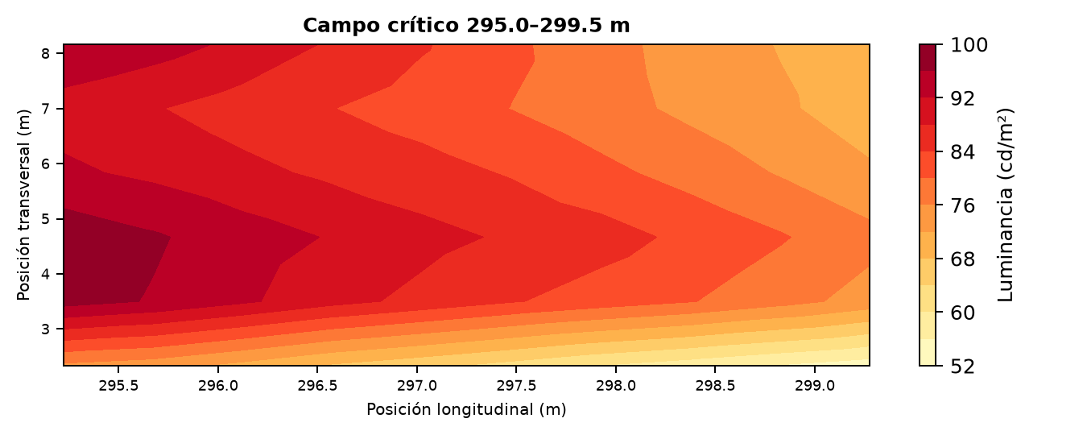

ANEXO C. Listado de Luminarias y Reglajes

Listado por posición longitudinal. Las coordenadas transversales y la configuración de filas se rigen por la disposición indicada en el informe principal.
Ref. | Zona | PK (m) | Modelo | Óptica | mA | W | Tilt | Capa
BASE A–B-1 | BASE A–B | -20.0 | APHEX_S_75W | F151 | 375.1 | 58.0 | 10.0° | Permanent
BASE A–B-2 | BASE A–B | 0.0 | APHEX_S_75W | F151 | 375.1 | 58.0 | 10.0° | Permanent
BASE A–B-3 | BASE A–B | 20.0 | APHEX_S_75W | F151 | 375.1 | 58.0 | 10.0° | Permanent
BASE A–B-4 | BASE A–B | 40.0 | APHEX_S_75W | F151 | 375.1 | 58.0 | 10.0° | Permanent
BASE A–B-5 | BASE A–B | 60.0 | APHEX_S_75W | F151 | 375.1 | 58.0 | 10.0° | Permanent
BASE A–B-6 | BASE A–B | 80.0 | APHEX_S_75W | F151 | 375.1 | 58.0 | 10.0° | Permanent
BASE A–B-7 | BASE A–B | 100.0 | APHEX_S_75W | F151 | 375.1 | 58.0 | 10.0° | Permanent
BASE A–B-8 | BASE A–B | 120.0 | APHEX_S_75W | F151 | 375.1 | 58.0 | 10.0° | Permanent
BASE A–B-9 | BASE A–B | 140.0 | APHEX_S_75W | F151 | 375.1 | 58.0 | 10.0° | Permanent
BASE A–B-10 | BASE A–B | 160.0 | APHEX_S_75W | F151 | 375.1 | 58.0 | 10.0° | Permanent
BASE A–B-11 | BASE A–B | 180.0 | APHEX_S_75W | F151 | 375.1 | 58.0 | 10.0° | Permanent
BASE A–B-12 | BASE A–B | 200.0 | APHEX_S_75W | F151 | 375.1 | 58.0 | 10.0° | Permanent
BASE A–B-13 | BASE A–B | 220.0 | APHEX_S_75W | F151 | 375.1 | 58.0 | 10.0° | Permanent
BASE A–B-14 | BASE A–B | 240.0 | APHEX_S_75W | F151 | 375.1 | 58.0 | 10.0° | Permanent
BASE A–B-15 | BASE A–B | 260.0 | APHEX_S_75W | F151 | 375.1 | 58.0 | 10.0° | Permanent
BASE A–B-16 | BASE A–B | 280.0 | APHEX_S_75W | F151 | 375.1 | 58.0 | 10.0° | Permanent
BASE A–B-17 | BASE A–B | 300.0 | APHEX_S_75W | F151 | 375.1 | 58.0 | 10.0° | Permanent
ADAPTACIÓN A-1 | ADAPTACIÓN A | 9.0 | APHEX_M_200Wx2 | F151 | 255.7 | 156.0 | 10.0° | Adaptation
ADAPTACIÓN A-2 | ADAPTACIÓN A | 27.0 | APHEX_M_200Wx2 | F151 | 255.7 | 156.0 | 10.0° | Adaptation
ADAPTACIÓN A-3 | ADAPTACIÓN A | 45.0 | APHEX_M_200Wx2 | F151 | 255.7 | 156.0 | 10.0° | Adaptation
ADAPTACIÓN A-4 | ADAPTACIÓN A | 63.0 | APHEX_M_200Wx2 | F151 | 255.7 | 156.0 | 10.0° | Adaptation
ADAPTACIÓN A-5 | ADAPTACIÓN A | 81.0 | APHEX_S_165W | F151 | 493.5 | 154.4 | 10.0° | Adaptation
ADAPTACIÓN A-6 | ADAPTACIÓN A | 99.0 | APHEX_S_165W | F151 | 374.0 | 115.4 | 10.0° | Adaptation
ADAPTACIÓN A-7 | ADAPTACIÓN A | 117.0 | APHEX_S_165W | F151 | 260.6 | 79.7 | 10.0° | Adaptation
ADAPTACIÓN A-8 | ADAPTACIÓN A | 135.0 | APHEX_S_75W | F151 | 322.6 | 49.7 | 10.0° | Adaptation
ADAPTACIÓN A-9 | ADAPTACIÓN A | 153.0 | APHEX_S_75W | F151 | 105.0 | 16.0 | 10.0° | Adaptation
ADAPTACIÓN B-1 | ADAPTACIÓN B | 165.0 | APHEX_S_75W | F151 | 105.0 | 16.0 | -10.0° | Adaptation
ADAPTACIÓN B-2 | ADAPTACIÓN B | 183.0 | APHEX_S_75W | F151 | 127.5 | 19.4 | -10.0° | Adaptation
ADAPTACIÓN B-3 | ADAPTACIÓN B | 201.0 | APHEX_S_75W | F151 | 264.1 | 40.5 | -10.0° | Adaptation
ADAPTACIÓN B-4 | ADAPTACIÓN B | 219.0 | APHEX_S_75W | F151 | 409.1 | 63.5 | -10.0° | Adaptation
ADAPTACIÓN B-5 | ADAPTACIÓN B | 237.0 | APHEX_S_165W | F151 | 242.5 | 74.1 | -10.0° | Adaptation
ADAPTACIÓN B-6 | ADAPTACIÓN B | 255.0 | APHEX_S_165W | F151 | 242.5 | 74.1 | -10.0° | Adaptation
ADAPTACIÓN B-7 | ADAPTACIÓN B | 273.0 | APHEX_S_165W | F151 | 242.5 | 74.1 | -10.0° | Adaptation
ADAPTACIÓN B-8 | ADAPTACIÓN B | 291.0 | APHEX_S_165W | F151 | 242.5 | 74.1 | -10.0° | Adaptation
CTH-1 | CTH | 0.5 | APHEX_L_320Wx2 | F2M2 | 483.5 | 450.9 | 20.0° | Reinforcement
CTH-2 | CTH | 1.0 | APHEX_L_320Wx2 | F2M2 | 483.5 | 450.9 | 20.0° | Reinforcement
CTH-3 | CTH | 5.5 | APHEX_L_320Wx2 | F2M2 | 483.5 | 450.9 | 20.0° | Reinforcement
CTH-4 | CTH | 6.0 | APHEX_L_320Wx2 | F2M2 | 483.5 | 450.9 | 20.0° | Reinforcement
CTH-5 | CTH | 10.5 | APHEX_L_320Wx2 | F2M2 | 483.5 | 450.9 | 20.0° | Reinforcement
CTH-6 | CTH | 11.0 | APHEX_L_320Wx2 | F2M2 | 483.5 | 450.9 | 20.0° | Reinforcement
CTH-7 | CTH | 15.5 | APHEX_L_320Wx2 | F2M2 | 483.5 | 450.9 | 20.0° | Reinforcement
CTH-8 | CTH | 16.0 | APHEX_L_320Wx2 | F2M2 | 483.5 | 450.9 | 20.0° | Reinforcement
CTH-9 | CTH | 20.5 | APHEX_L_320Wx2 | F2M2 | 483.5 | 450.9 | 20.0° | Reinforcement
CTH-10 | CTH | 21.0 | APHEX_L_320Wx2 | F2M2 | 483.5 | 450.9 | 20.0° | Reinforcement
CTH-11 | CTH | 25.5 | APHEX_L_320Wx2 | F2M2 | 482.4 | 449.9 | 20.0° | Reinforcement
CTH-12 | CTH | 26.0 | APHEX_L_320Wx2 | F2M2 | 474.9 | 442.5 | 20.0° | Reinforcement
CTH-13 | CTH | 30.5 | APHEX_L_320Wx2 | F2M2 | 468.6 | 436.3 | 20.0° | Reinforcement
CTH-14 | CTH | 31.0 | APHEX_L_320Wx2 | F2M2 | 468.6 | 436.3 | 20.0° | Reinforcement
CTH-15 | CTH | 35.5 | APHEX_L_320Wx2 | F2M2 | 468.6 | 436.3 | 20.0° | Reinforcement
CTH-16 | CTH | 36.0 | APHEX_L_320Wx2 | F2M2 | 468.6 | 436.3 | 20.0° | Reinforcement
CTH-17 | CTH | 40.5 | APHEX_L_320Wx2 | F2M2 | 468.6 | 436.3 | 20.0° | Reinforcement
CTH-18 | CTH | 41.0 | APHEX_L_320Wx2 | F2M2 | 468.6 | 436.3 | 20.0° | Reinforcement
CTH-19 | CTH | 45.5 | APHEX_L_320Wx2 | F2M2 | 468.6 | 436.3 | 20.0° | Reinforcement
CTH-20 | CTH | 46.0 | APHEX_L_320Wx2 | F2M2 | 468.6 | 436.3 | 20.0° | Reinforcement
CTH-21 | CTH | 50.5 | APHEX_L_320Wx2 | F2M2 | 468.6 | 436.3 | 20.0° | Reinforcement
CTH-22 | CTH | 51.0 | APHEX_L_320Wx2 | F2M2 | 468.6 | 436.3 | 20.0° | Reinforcement
CTH-23 | CTH | 55.5 | APHEX_L_320Wx2 | F2M2 | 468.6 | 436.3 | 20.0° | Reinforcement
CTH-24 | CTH | 56.0 | APHEX_L_320Wx2 | F2M2 | 468.6 | 436.3 | 20.0° | Reinforcement
CTH-25 | CTH | 60.5 | APHEX_L_320Wx2 | F2M2 | 468.6 | 436.3 | 20.0° | Reinforcement
CTH-26 | CTH | 61.0 | APHEX_L_320Wx2 | F2M2 | 468.6 | 436.3 | 20.0° | Reinforcement
CTH-27 | CTH | 65.5 | APHEX_L_320Wx2 | F2M2 | 468.6 | 436.3 | 20.0° | Reinforcement
CTH-28 | CTH | 66.0 | APHEX_L_320Wx2 | F2M2 | 468.6 | 436.3 | 20.0° | Reinforcement
CTH-29 | CTH | 70.5 | APHEX_L_320Wx2 | F2M2 | 468.6 | 436.3 | 20.0° | Reinforcement
CTH-30 | CTH | 71.0 | APHEX_L_320Wx2 | F2M2 | 468.6 | 436.3 | 20.0° | Reinforcement
CTH-31 | CTH | 75.5 | APHEX_L_320Wx2 | F2M2 | 458.4 | 426.2 | 20.0° | Reinforcement
CTH-32 | CTH | 76.0 | APHEX_L_320Wx2 | F2M2 | 456.2 | 424.1 | 20.0° | Reinforcement
CTH-33 | CTH | 80.5 | APHEX_L_320Wx2 | F2M2 | 436.7 | 405.1 | 20.0° | Reinforcement
CTH-34 | CTH | 81.5 | APHEX_L_320Wx2 | F2M2 | 434.6 | 403.0 | 20.0° | Reinforcement
CTH-35 | CTH | 85.5 | APHEX_L_320Wx2 | F2M2 | 415.3 | 384.4 | 20.0° | Reinforcement
CTH-36 | CTH | 86.0 | APHEX_L_320Wx2 | F2M2 | 413.2 | 382.4 | 20.0° | Reinforcement
CTH-37 | CTH | 90.5 | APHEX_L_320Wx2 | F2M2 | 394.2 | 364.1 | 20.0° | Reinforcement
CTH-38 | CTH | 91.0 | APHEX_L_320Wx2 | F2M2 | 392.1 | 362.0 | 20.0° | Reinforcement
CTH-39 | CTH | 95.5 | APHEX_L_320Wx2 | F2M2 | 373.2 | 344.0 | 20.0° | Reinforcement
CTH-40 | CTH | 96.0 | APHEX_L_320Wx2 | F2M2 | 371.1 | 342.0 | 20.0° | Reinforcement
CTH-41 | CTH | 100.5 | APHEX_L_320Wx2 | F2M2 | 352.4 | 324.2 | 20.0° | Reinforcement
CTH-42 | CTH | 101.0 | APHEX_L_320Wx2 | F2M2 | 350.3 | 322.3 | 20.0° | Reinforcement
CTH-43 | CTH | 105.5 | APHEX_L_320Wx2 | F2M2 | 331.7 | 304.8 | 20.0° | Reinforcement
CTH-44 | CTH | 106.0 | APHEX_L_320Wx2 | F2M2 | 329.7 | 302.8 | 20.0° | Reinforcement
CTH-45 | CTH | 110.5 | APHEX_M_200Wx2 | F2M2 | 488.1 | 304.2 | 20.0° | Reinforcement
CTH-46 | CTH | 111.0 | APHEX_M_200Wx2 | F2M2 | 484.8 | 302.0 | 20.0° | Reinforcement
CTH-47 | CTH | 115.5 | APHEX_M_200Wx2 | F2M2 | 455.3 | 282.6 | 20.0° | Reinforcement
CTH-48 | CTH | 116.0 | APHEX_M_200Wx2 | F2M2 | 452.0 | 280.5 | 20.0° | Reinforcement
CTH-49 | CTH | 120.5 | APHEX_M_200Wx2 | F2M2 | 423.0 | 261.6 | 20.0° | Reinforcement
CTH-50 | CTH | 121.0 | APHEX_M_200Wx2 | F2M2 | 419.8 | 259.5 | 20.0° | Reinforcement
CTH-51 | CTH | 125.5 | APHEX_M_200Wx2 | F2M2 | 391.2 | 241.1 | 20.0° | Reinforcement
CTH-52 | CTH | 126.0 | APHEX_M_200Wx2 | F2M2 | 388.0 | 239.1 | 20.0° | Reinforcement
CTH-53 | CTH | 130.5 | APHEX_M_200Wx2 | F2M2 | 359.8 | 221.1 | 20.0° | Reinforcement
CTH-54 | CTH | 131.0 | APHEX_M_200Wx2 | F2M2 | 356.7 | 219.2 | 20.0° | Reinforcement
CTH-55 | CTH | 135.5 | APHEX_M_200Wx2 | F2M2 | 328.8 | 201.6 | 20.0° | Reinforcement
CTH-56 | CTH | 136.0 | APHEX_M_200Wx2 | F2M2 | 325.8 | 199.7 | 20.0° | Reinforcement
CTH-57 | CTH | 140.5 | APHEX_M_200Wx2 | F2M2 | 298.3 | 182.5 | 20.0° | Reinforcement
CTH-58 | CTH | 141.0 | APHEX_M_200Wx2 | F2M2 | 295.3 | 180.6 | 20.0° | Reinforcement
CTR1-1 | CTR1 | 148.5 | APHEX_L_320Wx2 | F151 | 417.4 | 386.4 | 15.0° | Reinforcement
CTR1-2 | CTR1 | 154.5 | APHEX_L_320Wx2 | F151 | 341.1 | 313.6 | 15.0° | Reinforcement
CTR1-3 | CTR1 | 160.5 | APHEX_L_320Wx2 | F151 | 391.3 | 361.3 | 15.0° | Reinforcement
CTR1-4 | CTR1 | 168.5 | APHEX_L_320Wx2 | F151 | 404.1 | 373.6 | 15.0° | Reinforcement
CTR1-5 | CTR1 | 178.5 | APHEX_L_320Wx2 | F2M2 | 447.6 | 415.7 | 20.0° | Reinforcement
CTR1-6 | CTR1 | 192.5 | APHEX_L_320Wx2 | F2M2 | 442.6 | 410.8 | 20.0° | Reinforcement
CTR1-7 | CTR1 | 210.5 | APHEX_L_320Wx2 | F2M2 | 361.8 | 333.1 | 20.0° | Reinforcement
CTR1-8 | CTR1 | 230.5 | APHEX_L_320Wx2 | F151 | 334.1 | 307.0 | 10.0° | Reinforcement
CTR1-9 | CTR1 | 250.5 | APHEX_M_200Wx2 | F151 | 398.3 | 245.7 | 10.0° | Reinforcement
CTR1-10 | CTR1 | 270.5 | APHEX_M_200Wx2 | F151 | 311.2 | 190.5 | 10.0° | Reinforcement
CTR1-11 | CTR1 | 290.5 | APHEX_M_200Wx2 | F151 | 248.1 | 151.3 | 10.0° | Reinforcement
CTR2·B-1 | CTR2·B | 10.0 | APHEX_S_75W | F151 | 344.9 | 53.2 | 15.0° | Reinforcement
CTR2·B-2 | CTR2·B | 30.0 | APHEX_S_75W | F151 | 460.1 | 71.9 | 15.0° | Reinforcement
CTR2·B-3 | CTR2·B | 50.0 | APHEX_S_165W | F151 | 286.2 | 87.6 | 15.0° | Reinforcement
CTR2·B-4 | CTR2·B | 70.0 | APHEX_S_165W | F151 | 386.3 | 119.3 | 15.0° | Reinforcement
CTR2·B-5 | CTR2·B | 90.0 | APHEX_M_200Wx2 | F151 | 249.6 | 152.2 | 15.0° | Reinforcement
CTR2·B-6 | CTR2·B | 110.0 | APHEX_M_200Wx2 | F151 | 356.2 | 218.9 | 15.0° | Reinforcement
CTR2·B-7 | CTR2·B | 130.0 | APHEX_L_320Wx2 | F151 | 346.1 | 318.4 | 15.0° | Reinforcement
CTR2·B-8 | CTR2·B | 148.0 | APHEX_L_320Wx2 | F151 | 418.5 | 387.4 | 20.0° | Reinforcement
CTH·B-1 | CTH·B | 164.5 | APHEX_M_200Wx2 | F151 | 248.9 | 151.8 | 20.0° | Reinforcement
CTH·B-2 | CTH·B | 169.0 | APHEX_M_200Wx2 | F151 | 276.1 | 168.6 | 20.0° | Reinforcement
CTH·B-3 | CTH·B | 173.5 | APHEX_M_200Wx2 | F151 | 303.6 | 185.8 | 20.0° | Reinforcement
CTH·B-4 | CTH·B | 178.0 | APHEX_M_200Wx2 | F151 | 331.4 | 203.2 | 20.0° | Reinforcement
CTH·B-5 | CTH·B | 182.5 | APHEX_M_200Wx2 | F151 | 359.6 | 221.0 | 20.0° | Reinforcement
CTH·B-6 | CTH·B | 187.0 | APHEX_M_200Wx2 | F151 | 388.2 | 239.2 | 20.0° | Reinforcement
CTH·B-7 | CTH·B | 191.5 | APHEX_M_200Wx2 | F151 | 417.1 | 257.8 | 20.0° | Reinforcement
CTH·B-8 | CTH·B | 196.0 | APHEX_M_200Wx2 | F151 | 446.4 | 276.8 | 20.0° | Reinforcement
CTH·B-9 | CTH·B | 200.5 | APHEX_M_200Wx2 | F151 | 476.1 | 296.2 | 20.0° | Reinforcement
CTH·B-10 | CTH·B | 205.0 | APHEX_L_320Wx2 | F151 | 322.4 | 296.0 | 20.0° | Reinforcement
CTH·B-11 | CTH·B | 209.5 | APHEX_L_320Wx2 | F151 | 341.1 | 313.6 | 20.0° | Reinforcement
CTH·B-12 | CTH·B | 214.0 | APHEX_L_320Wx2 | F151 | 359.9 | 331.4 | 20.0° | Reinforcement
CTH·B-13 | CTH·B | 218.5 | APHEX_L_320Wx2 | F151 | 378.9 | 349.5 | 20.0° | Reinforcement
CTH·B-14 | CTH·B | 223.0 | APHEX_L_320Wx2 | F151 | 398.1 | 367.8 | 20.0° | Reinforcement
CTH·B-15 | CTH·B | 227.5 | APHEX_L_320Wx2 | F151 | 417.4 | 386.4 | 20.0° | Reinforcement
CTH·B-16 | CTH·B | 232.0 | APHEX_L_320Wx2 | F151 | 435.4 | 403.8 | 20.0° | Reinforcement
CTH·B-17 | CTH·B | 236.5 | APHEX_L_320Wx2 | F151 | 435.4 | 403.8 | 20.0° | Reinforcement
CTH·B-18 | CTH·B | 241.0 | APHEX_L_320Wx2 | F151 | 435.4 | 403.8 | 20.0° | Reinforcement
CTH·B-19 | CTH·B | 245.5 | APHEX_L_320Wx2 | F151 | 435.4 | 403.8 | 20.0° | Reinforcement
CTH·B-20 | CTH·B | 250.0 | APHEX_L_320Wx2 | F151 | 435.4 | 403.8 | 20.0° | Reinforcement
CTH·B-21 | CTH·B | 254.5 | APHEX_L_320Wx2 | F151 | 435.4 | 403.8 | 20.0° | Reinforcement
CTH·B-22 | CTH·B | 259.0 | APHEX_L_320Wx2 | F151 | 435.4 | 403.8 | 20.0° | Reinforcement
CTH·B-23 | CTH·B | 263.5 | APHEX_L_320Wx2 | F151 | 435.4 | 403.8 | 20.0° | Reinforcement
CTH·B-24 | CTH·B | 268.0 | APHEX_L_320Wx2 | F151 | 435.4 | 403.8 | 20.0° | Reinforcement
CTH·B-25 | CTH·B | 272.5 | APHEX_L_320Wx2 | F151 | 481.5 | 449.0 | 20.0° | Reinforcement
CTH·B-26 | CTH·B | 277.0 | APHEX_L_480Wx2 | F151 | 500.0 | 467.3 | 20.0° | Reinforcement
CTH·B-27 | CTH·B | 277.5 | APHEX_S_75W | F151 | 215.1 | 32.8 | 20.0° | Reinforcement
CTH·B-28 | CTH·B | 281.5 | APHEX_L_480Wx2 | F151 | 500.0 | 467.3 | 20.0° | Reinforcement
CTH·B-29 | CTH·B | 286.0 | APHEX_L_480Wx2 | F151 | 500.0 | 467.3 | 20.0° | Reinforcement
CTH·B-30 | CTH·B | 290.0 | APHEX_L_480Wx2 | F151 | 500.0 | 467.3 | 20.0° | Reinforcement
CTH·B-31 | CTH·B | 295.0 | APHEX_L_480Wx2 | F151 | 500.0 | 467.3 | 20.0° | Reinforcement
CTH·B-32 | CTH·B | 299.5 | APHEX_L_480Wx2 | F151 | 500.0 | 467.3 | 20.0° | Reinforcement

